Endorsement guideline protocol actuality problem

Preface

TABLE OF CONTENTS
1. SOFTWARE DEVELOPMENT LIFE CYCLE
2. PLATFORM KNOWLEDGE
3. ABOUT PROJECT
3.1 ABSTRACT
3.2 SCOPE OF THE PROJECT
3.3 EXISTING SYSTEM
3.3.1 DISADVANTAGES
3.4 PROPOSED SYSTEM
3.4.1 ADVANTAGES
4. BOTTOM LINE AND FUTURE ENHANCEMENT

5. SOFTWARE AND HARDWARE REQUIREMENTS

1. SDLC (Software Development Life Cycle)
The Software Development Life Cycle is a systematic process for building software that ensures the quality and correctness of the software built. SDLC process aims to produce high-quality software which meets customer expectations. The software development should be completed within the pre-defined time frame and cost.

SDLC Phases
The entire SDLC process is divided into the following stages:
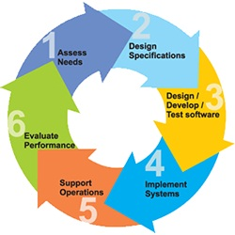
- Phase 1: Requirement collection and analysis
- Phase 2: Feasibility study
- Phase 3: Design
- Phase 4: Coding
- Phase 5: Testing
- Phase 6: Installation/Deployment
- Phase 7: Maintenance

2. Platform Knowledge
Introduction to Python:
Python is developed by Guido van Rossum. Guido van Rossum started implementing Python in 1989. Python is a facile programming language so even if you are new to programming, you can learn python without facing any issues. Python is a general-purpose programming language that is becoming ever more popular for data science. Companies worldwide are using Python to harvest insights from their data and gain a competitive edge. Python specifically for data science. To store and manipulate data, and helpful data science tools to begin conducting your own analyses.
What is Python?
Python is an interpreted, high-level, general purpose programming language. It is dynamically typed and collected. Python is an interpreted language and not a compiled one, although compilation is a step. Python code, written in .py file is first compiled to what is called byte code which is stored with a .pyc or .pyo format. Instead of translating source code to machine code like C++, Python code it translated to byte code. This byte code is a low-level set of instructions that can be executed by an interpreter. One popular advantage of interpreted languages is that they are platform-independent. As long as the Python byte code and the Virtual Machine have the same version, Python byte code can be executed on any platform (Windows, MacOS, etc).Dynamic typing is another advantage. In static-typed languages like C++, you have to declare the variable type and any discrepancy like adding a string and an integer is checked during compile time. In older programming languages, memory allocation was quite manual. Many times when you use variables that are no longer in use or referenced anywhere else in the program, they need to be cleaned from the memory. Garbage Collector does that for you.
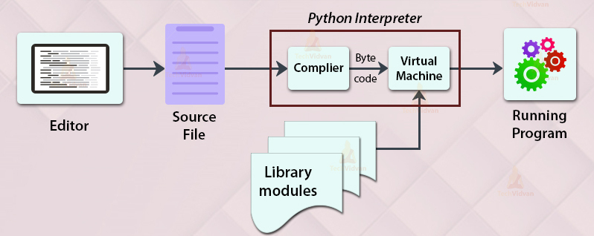
Domain:
Secure Computing:
A security system identifies and mitigates the system vulnerabilities, by either removing them, or restricting access to them, to a very small group. The competition between inventing new security measures to protect data and inventing hacking techniques in conjunction with discovering and leveraging pre-existing vulnerabilities is infinite. Therefore, securing data and resources is becoming more and more challenging day by day. Nevertheless, there exist several different techniques to secure the data being transferred over a network and also that on a user machine. Specializes in securing data in motion through the use of the patented REL-ID based mutual authentication scheme. SSL is one such tool to secure data sent over a network, using cipher text. Using SSL data is kept confidential and message integrity is maintained. However, recently there have been network security breaches, including the famous.it can be used to ensure that the end user is secured as well as the tunnel. It also uses techniques of authentication to assure to each end user that it is communicating with an authorized user and not a fake one. Such security measures are used to secure data in motion, meaning data that has been shared between computers. They may prove to be of minimum value, if the operating system on which it resides is compromised. It is therefore crucial to understand and remove the security flaws in the operating system itself. We, on the other hand, are trying to secure data at rest, by coming up with various approaches, one of which is application white listing. Hardening is a technique to reduce vulnerabilities of the existing operating system. It aims to eliminate security risks in an operating system. This is done by turning off all those services of the operating system which are not used are risky and allowing only those which are secure for user’s data. Thus, this environment becomes a kind of locked down or reduce version of a fully-fledged operating system. Operating system hardening is a technique which allows us a security on the machine level. A hardened operating system can be considered as a smaller version of an otherwise compromised operating system. Secondly, we implement a technique called as application white-listing. It is the technique of preparing a list of all applications that are safe to execute. All applications that excluded from this list are disallowed to spawn.

Endorsement guideline protocol actuality problem
3. About the Project
3.1 Abstract
Access control is a fundamental aspect of the security of any multi-user computing system, and is typically based on the specification and enforcement of an authorization policy. Such a policy identifies which interactions between users and resources are to be allowed by the system. Over the last twenty years, authorization policies have become more complex, not least because of the introduction of constraints, which further refine an authorization policy. A separation-of-duty constraint also known as the two man rule or four-eyes policy may, for example, require that no single user is authorized for some particularly. sensitive group of resources. Such a constraint is typically used to prevent misuse of the system by a single user. The use of authorization policies and constraints, by design, limits which users may access resources. Nevertheless, the ability to perform one’s duties requires access to particular resources, and overly prescriptive policies and constraints may mean that some resources are inaccessible. In short, tension may exist between authorization policies and operational demands: too lax a policy may suit organizational demands but lead to security violations; whereas too restrictive a policy may compromise an organization’s ability to meet its business objectives.
3.2 Scope of the project
Secure computing is a forward looking, highly sophisticated and secure distributed record keeping system which will help in the storage and analysis of large amount of documents database which can be traced down to all workers. The system would include all the entry and exit records documents involved in the and hence accord transparent The model is based on consensus and hence all the documents will have to be validated and approved of, by all the members of the group before it goes to contractor. The main purpose scope of the project is ONGC is the one of the leading corporation of india so the process is maintained highly secured only the authorised login only can access the documents and project .The concept of secure computing has taken the fancy of a lot of people and the technology became famous because of one of its most popular use cases.

3.3 Existing System
Constraints such as separation-of-duty are widely used to specify requirements that supplement basic authorization policies. However, the existence of constraints and authorization policies may mean that a user is unable to fulfil her/his organizational duties because access to resources has been denied. In short, there is a tension between the need to protect resources using policies and constraints and the availability of resources. Recent work on workflow satisfiability and resiliency in access control asks whether this tension compromises the ability of an organization to achieve its objectives. In this paper, we develop a new method of specifying constraints which subsumes much related work and allows a wider range of constraints to be specified. The use of such constraints leads naturally to a range of questions related to policy existence, where a positive answer means that an organization’s objectives can be realized. We analyse the complexity of these policy existence questions and, for particular sub-classes of constraints defined by our language, develop fixed-parameter tractable algorithms to solve them.
3.3.1 Disadvantages
- High authority people should pass their orders individually
- Time should be complex
- Security mismatching should be offensively occurs
- Firewalls can be difficult to configure correctly.

3.4 Proposed System
We proposed in this project added some security patches in ongc corporation there will be a different level of employees are there that employees have a some kind of work after they complete the work they are reported to engineers the engineers are stored the data there will be some data losses can be takes place like a employees also stolen the data for preventing these kind of action we used authorised login only the one user can the data the could not be stored the data’s are hidden after login once they show the data’s enter the unique key of her mail after entering key they check after the file is open. For different times login there will be unique key will be different .the engineer like to transfer data to such kind of employees approval from engineer they access the data’s.

3.4.1 Advantages
- It is highly secured
- Rare case of data’s can be loss
- Its takes a less time and mismatching of data’s
- Protects system against viruses, worms, spyware and other unwanted programs.
- Protection against data from theft.
- Protects the computer from being hacked.
- Minimizes computer freezing and crashes.
- Gives privacy to users.

4. Bottom line and Future Enhancement
In this paper we have introduced a general framework within which we can specify problems concerned with finding authorization relations (“policies”) that must satisfy certain kinds of constraints. We have shown that there exist FPT algorithms to solve the authorization policy existence problem when all constraints are user-independent and are bounded in an appropriate way. We have also shown that many constraints of practical interest are indeed user independent and bounded. Our prior work on implementing FPT algorithms for We believe there are many opportunities for future work, not least exploring what types of authorization constraints might be useful in practice and determining whether those constraints are user-independent and bounded.

5. Hardware and Software Requirements
HARDWARE REQUIREMENTS:
- Processor : Intel (R) Pentium (R)
- Speed : 1.6 GHz and Above.
- RAM : 4 GB and Above.
- Hard Disk : 120 GB.
- Monitor : 15’’ LED SVGA
- Input Devices : Keyboard, Mouse.

SOFTWARE REQUIREMENTS:
- Operating system : Windows 7 / 8 / 8.1 / 10.
- Coding Language : PYTHON.
- IDE : PyCharm.
- Database : MySQL

